DOKUZ EYLUL UNIVERSITY
ENGINEERING FACULTY
DEPARTMENT OF COMPUTER ENGINEERING

CME1251 PROJECT BASED LEARNING – I
FINAL REPORT
PROJECT – I

TRIANGLE BATTLESHIP

by
Gürkan Bıyık
Yusuf Badakol
Yasin Atıcı

Lecturers
Instructor Şerife Yılmaz
Res.Asst. Fatih Dicle

03.11.2021

CHAPTER ONE
PROGRESS DESCRIPTION
Purpose of the project is using the informations that we learned from the lectures we had. We used while loops for to play the game again and again. While in the loop, we used if, else if, else for the option which we want to choose. We used Math library in C# for the calculating the ship propeties. For the coordinate system we made a string variable. Then, we added the dots to the this string variable. First week, we coded printing menu and taking input from the player. Also, we printed the basic properities of the ship. Second week, we made a coordinate system. Third week, we completed the all properities of the ship. Last week, we made the high score table.

CHAPTER TWO
TASK SUMMARY

Completed Tasks
Gürkan Bıyık; I coded how to print the coordinate system and write the locations of triangle’s corners on the coordinate system. I wrote the codes calculating the angles and median points. I converted the source codes to the form that we can play again an again.

Yusuf Badakol; I printed the menu. I wrote the formula of the central bisector. I will check if the triangle is correct with some formulas. I checked if the triangle is correct with some formulas.

Yasin Atıcı; I searched basic properties and done them (The size of the ship (length of the edges), the perimeter of the ship, the area of the ship). I am searched a formula about "The area of the inscribed and circumscribed circles and The type of the ship". I worked on whether the ship will sink or not.

Incomplete Tasks: Reasons and Explanations
Gürkan Bıyık; -
Yusuf Badakol; -
Yasin Atıcı; -

Additional Improvements to the Project
Gürkan Bıyık; I could have prevent a problem in the source code. That when we take other than numbers input the program is crashed.
Yusuf Badakol; -
Yasin Atıcı; -

CHAPTER THREE
EXPLANATION of algorıthms

Screenshots
COORDINATE SYSTEM
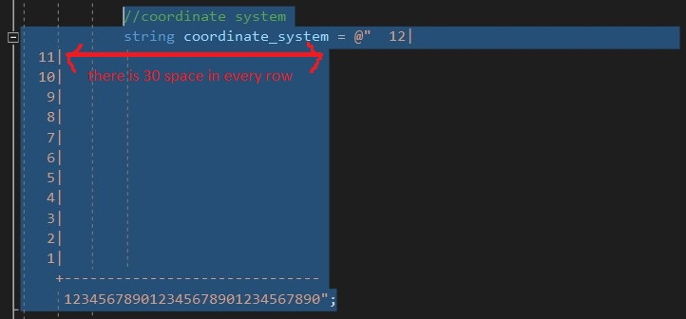
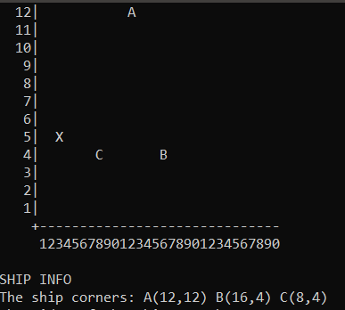

HIGH SCORE TABLE
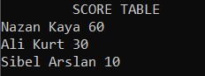

Functions
string.Substring, string.Contains, Math.Pow, Math.Round, Math.Sqrt, Math.Abs, Math.asin, Math.PI, rand.Next

Algorithms and Solution Strategies

Gürkan Bıyık; I created the coordinate system in string type. Every dot in the 30x12 cartesian coordinate system has a space. So, we have “12| “ string like that. I made a variable that returns index of triangle corner with using the x,y values of the corner. Then, the corner name is added to coordinate system with using substrings trough that variable as the index.

Yusuf Badakol; I wrote the random fire code.

Yasin Atıcı; I calculated the basic properties of the triangle with the entered coordinates. I used Math.Abs , area formula and perimeter formula in the project.
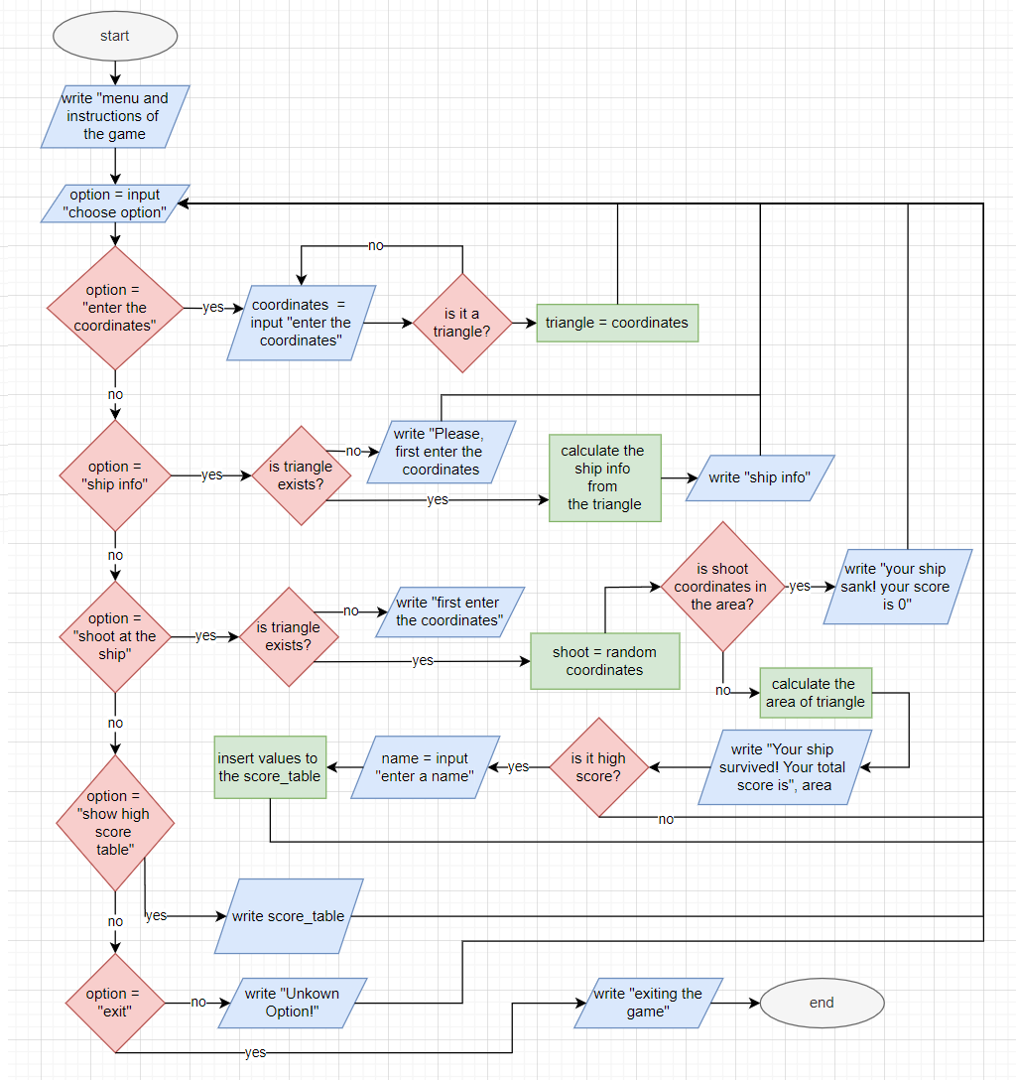
Flowchart

CHAPTER FOUR
PROBLEMS ENCOUNTERED
Gürkan Bıyık; Spesific index of a string is can’t be changed.

Yusuf Badakol; I got a data type error and fixed it by entering the appropriate data type.

Yasin Atıcı; In some numbers entered, the area was negative, I solved this with the Math.Abs function.

CHAPTER FIVE
conclusıon
During the project, we learned to use the time correctly, to work as a team, and to distribute the work. Technically, we had the opportunity to reinforce some of the new topics we learned: using if else when working with conditions, printing anything we want, getting data from the user and assigning the data, data types, changing data types, while loops, using some math labs, do mathematical operations.

REFERENCES
https://www.eokultv.com/kosinus-teoremi-ve-sinus-teoremi-11-sinif/19890/11-sinif-sinus-alan-formulu-1

https://www.matematiktutkusu.com/forum/geometri-formulleri/2393-ucgende-alan-formulleri-ucgenin-alan-formulu-bagintilari.html

https://trakademi.com/aciortay/

https://umitsen.wordpress.com/2013/04/07/nokta-ucgenin-icinde-mi-degil-mi-test-etme/

https://www.techiedelight.com/replace-character-specific-position-string-csharp/

AppendIx A
Poster/Web page of the Project
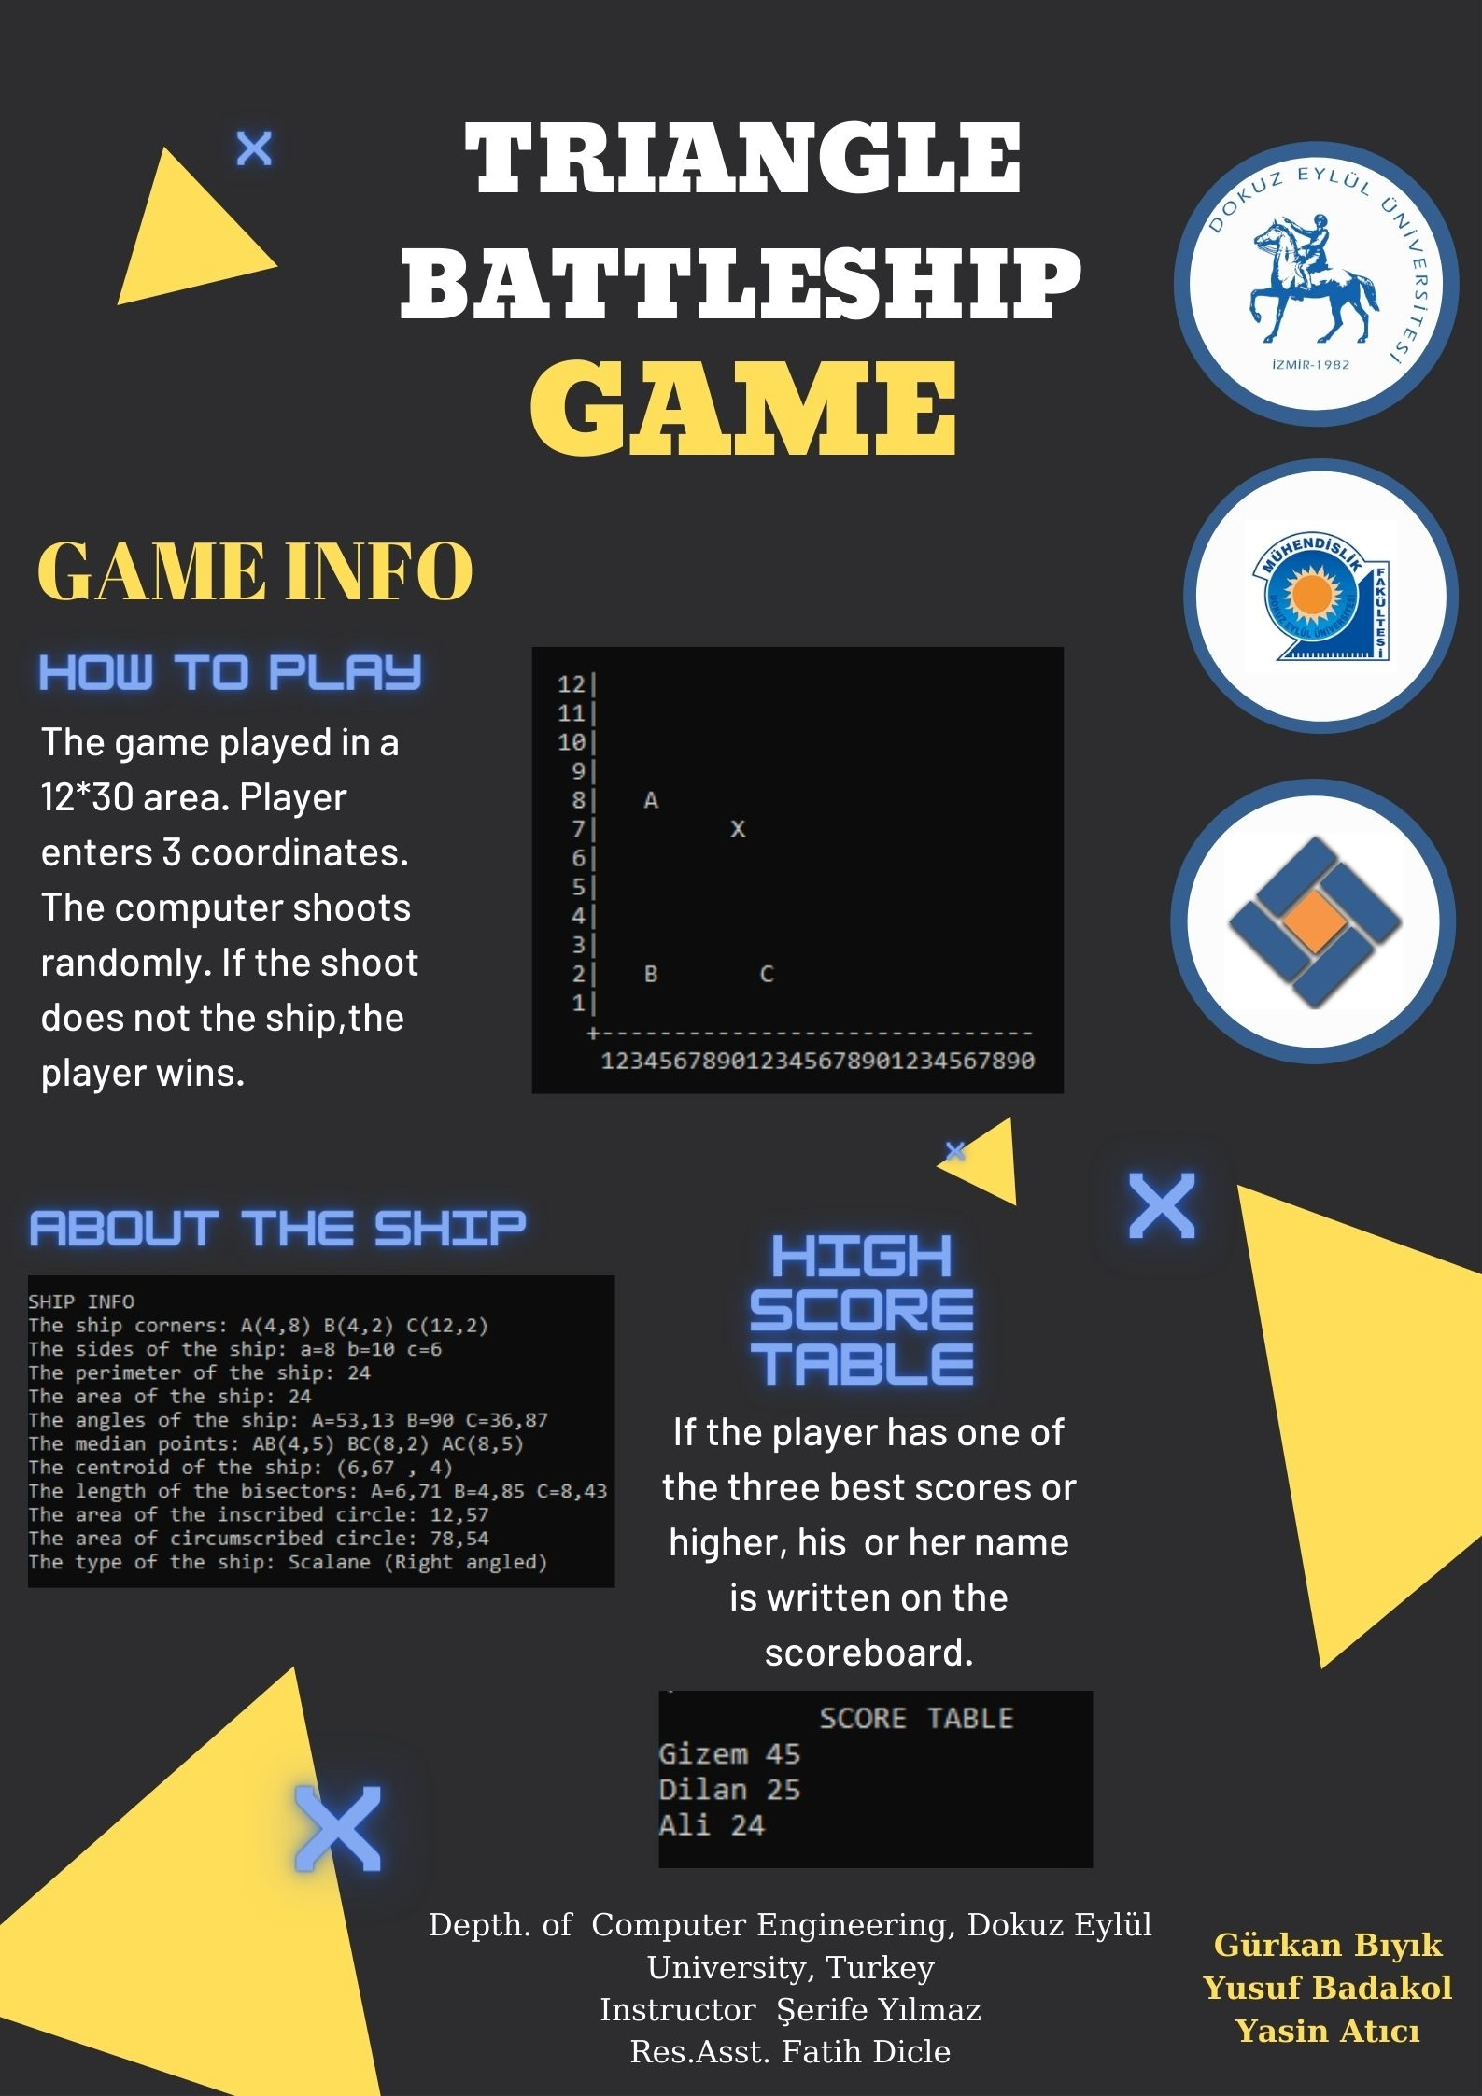
Poster
AppendIx B
Code of the Project
HOW WE ADDED DOTS TO THE COORDINATE SYSTEM
//coordinate system
(after the every vertical line ( | ) in y axis we have 30 space. So, we can add any dot instead of those space. We do it from using its index that the space that we want to change)
coordinate_system = @" 12|
11|
10|
9|
8|
7|
6|
5|
4|
3|
2|
1|
+------------------------------
123456789012345678901234567890";

//take the coordinates
Console.WriteLine("\nFirst coordinate Ax(Min 1 Max 30):");
Ax = Convert.ToInt32(Console.ReadLine());
Console.WriteLine("First coordinate Ay(Min 1 Max 12):");
Ay = Convert.ToInt32(Console.ReadLine());
Console.WriteLine("Second coordinate Bx(Min 1 Max 30):");
Bx = Convert.ToInt32(Console.ReadLine());
Console.WriteLine("Second coordinate By(Min 1 Max 12):");
By = Convert.ToInt32(Console.ReadLine());
Console.WriteLine("Third coordinate Cx(Min 1 Max 30):");
Cx = Convert.ToInt32(Console.ReadLine());
Console.WriteLine("Third coordinate Cy(Min 1 Max 12):");
Cy = Convert.ToInt32(Console.ReadLine());

//checking coordinates entered correcrtly
if ( (1 <= Ax && Ax <= 30 && 1 <= Bx && Bx <= 30 && 1 <= Cx && Cx <= 30 && 1 <= Ay && Ay <= 12 && 1 <= By && By <= 12 && 1 <= Cy && Cy <= 12) == false)
{
Console.WriteLine("Incorrect coordinates! Please enter a value between 1-30!");
continue;
}
//continue if coordinates entered correctly
else
{
//calculating the sides of the triangle
a = Math.Pow(Math.Pow(Math.Abs(Bx - Cx), 2) + Math.Pow(Math.Abs(By - Cy), 2), 0.5);
b = Math.Pow(Math.Pow(Math.Abs(Ax - Cx), 2) + Math.Pow(Math.Abs(Ay - Cy), 2), 0.5);
c = Math.Pow(Math.Pow(Math.Abs(Bx - Ax), 2) + Math.Pow(Math.Abs(By - Ay), 2), 0.5);

//checking if it is a triangle
bool is_it_a_triangle = ((Math.Abs(b - c) < a && a < b + c) && (Math.Abs(a - c) < b && b < a + c) && (Math.Abs(b - a) < c && c < b + a));
if (is_it_a_triangle == false)
{
Console.WriteLine("\nThis coordinates can't make a triangle. Try Again!");
continue;
}

//calculating the position of dot in coordinate system (e.g. 250. index)
int index_A = ((37 * (12 - Ay)) + (Ax + 4));
int index_B = ((37 * (12 - By)) + (Bx + 4));
int index_C = ((37 * (12 - Cy)) + (Cx + 4));

//replacing the dots to the coordinate_system
coordinate_system = coordinate_system.Substring(0, index_A) + "A" + coordinate_system.Substring(index_A + 1);
coordinate_system = coordinate_system.Substring(0, index_B) + "B" + coordinate_system.Substring(index_B + 1);
coordinate_system = coordinate_system.Substring(0, index_C) + "C" + coordinate_system.Substring(index_C + 1);
}

HOW WE ORDERLY INSERT THE VALUES TO THE SCORE TABLE
//score table
string first_name = "Gizem", second_name = "Dilan", third_name = "Murat";
double first_score = 65, second_score = 28, third_score = 12;
-----------------------------------------------------------------------------------------------------------------
//return if ship sink
if (ship_sink != true)
{
Console.WriteLine("Your ship survived! Your total score is: " + Math.Round(area, 2));

//insert values to score table orderly in every case if player get high score
if (area > third_score)
{
Console.WriteLine("HIGH SCORE! Enter your nick:");
string winner = Console.ReadLine();

if (area > first_score)
{
first_name = winner;
first_score = area;
}
else if (area == first_score && area != second_score)
{
second_name = winner;
second_score = area;
}
else if (area > second_score)
{
second_name = winner;
second_score = area;
}
else if (area == second_score && area != third_score)
{
third_name = winner;
third_score = area;
}
else if (area > third_score)
{
third_name = winner;
third_score = area;
}
}
}
else
{
Console.WriteLine("Your ship sank!");
}
}
//score table
else if (option == "4")
{
Console.WriteLine(" SCORE TABLE");
Console.WriteLine(first_name + " " + Math.Round(first_score,2));
Console.WriteLine(second_name + " " + Math.Round(second_score, 2));
Console.WriteLine(third_name + " " + Math.Round(third_score, 2));
}

